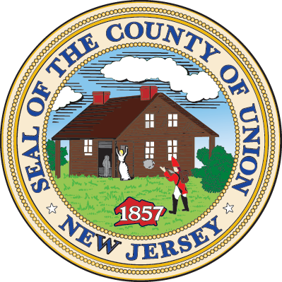
Contact Leon Grebla  Telephone (908) 298-7849  Email warinancopark@gmail.com  Website http://www.warinancopark.com | FOR IMMEDIATE RELEASE  October 24, 2017

GRAND OPENING OF WARINANCO SPORTS CENTER

Warinanco Park’s ice skating rink facility re-opens its doors with new and improved amenities.
Roselle, New Jersey, October 24, 2017– The Union County Board of Chosen Freeholders proudly announces the grand re-opening of the Warinanco Sports Center on November 4, 2017, and invites the community to see the facility’s newest remodel and updated amenities. The grand opening event will include appearances from the Cranford Hockey Club, general open skate sessions, Union County Department of Parks and Recreation exposition, and the county famous Union County Battle of the Badges hockey game.
The recent renovation project will cater to local residents in a whole new way by providing an 11,000 square foot state-of-the-art facility in the heart of the county park, complete with meeting spaces for events, a café for visitors as well as catering services, and a brand-new ice rink floor. These are just a few of the notable updates, with all components truly capturing the original title of the rink as “The First Public Artificial Ice Staking Rink in Union County.”
“The new Warinanco Sports Center is a place where families will continue to make great memories,” said Freeholder Vice Chairman Sergio Granados, who is also the Freeholder Board’s Parks and Recreation Advisory Board liaison. “We’ve completed an imaginative re-creation of the historic landmark for residents of Union County and surrounding areas.”
One of the great aspects of the two-phase project is the multipurpose use of the facility during the Spring and Summer months versus the Fall and Winter months. When the ice is removed from the rink floor in early Spring, field turf will be laid down to cater to the prominent baseball and softball community. This will allow the facility to be used as a year-round sports venue, in addition to the new amenities that will allow the facility to be used for far more than just sport.
The community grand opening event is open to the general public on November 4th, with events beginning at 7:00am EST going into the evening. The Warinanco Sports Center staff encourages everyone to bring family and friends to visit the brand-new facility, meet the Parks and Recreation department, and watch the Union County Police force battle the hockey rink against the Union County fire department teams. The Warinanco Café will also be open all day serving dishes such as signature burgers, fresh salads, and specialty plates made fresh to order.
# # #
Warinanco Sports Center has been a landmark for Union County skaters since 1961, and recently received an extensive $7 million modernization and renovation doubling the complex space and transforming it into a year-round venue for sports such as ice skating, hockey, baseball, and softball. In addition to a sports venue, the facility will also double as a meeting and events space for luncheons, cocktail parties, and corporate occasions.
If you would like more information about this topic, please contact Leon Grebla at (908) 298-7849 or email at warinancopark@gmail.com.

